|  |  |
| --- | --- |
|  | Project Specification |
|  |  |
| 4/29/2013 | Auto Indexer |
|  | This phase of project allows auto indexing to be part of RF.com website. This allows automatic extraction and allocation from |

Contents

Use Cases 2

Auto Indexer 2

Indexer Process 2

UC-PKI-AI-2 - Indexer Process 2

Extract Process 9

UC-PKI-AI-8 - Extract Process 9

Actors 14

Requirements 15

Glossary 16

Open Issues 17

# Use Cases

## Auto Indexer

This phase of project allows auto indexing to be part of RF.com website. This allows automatic extraction and allocation from

## Indexer Process

### UC-PKI-AI-2 - Indexer Process

It allows Indexer to verify the extracted data.

|  |  |
| --- | --- |
| Preconditions Authenticated Indexer is logged in. | Success Guarantee PDF file is assigned to the Auditor |

#### Main Success Scenario

1. Indexer Clicks on Indexing process in admin panel
2. System checks for Pdf which has PdfFileStsId as 'Indexer work in progress'
3. If No Pdf File found
   1. System checks for pdf which has PdfFileStsId as 'Extract Full','Extract Parital','Extract None' or 'DuplicateFiling'
   2. If Pdf File Found.
   3. Continue step No. 4
4. System opens pdf file in different window DGM-Indexer PDF Window.ndx
5. System populates all data fields in the data section in form DGM-Indexer Extract Screen.ndx based on pdfFileId.
6. System checks for PdfFileStsId is 'DuplicateFiling'
7. PdfFileStsId is Not 'DuplicateFiling'
   1. Continue step No. 7
8. System displays the File no,File Name,Path,Traking no.
9. System displays User ID of Indexer in the field "Entered By" and it is not editable.
10. Indexer chooses the Rotate angle in the drop down.
11. Indexer clicks on rotate Button.
    1. System rotates pdf file based on the rotate angle.
12. Indexer enters the text in the text box of search.
13. Indexer clicks on search button.
    1. System searches the text in pdf file.
14. Indexer clicks on Zoom in Button.
    1. System increases the zoom size by 20%.
15. Indexer clicks on zoom out.
    1. System decreases the zoom size by 20%.
16. Indexer clicks on delete button.
    1. System pops up message for confirmation.
       1. Indexer clicks on "Yes"
          1. System closes pop up message
          2. System deletes the current page.
17. Indexer verifies/modify data entry form.
18. Indexer selects state from the drop down list.
19. Indexer selects prefix from the drop down list.
    1. System automatically populated Prefix field from the Sub TOI table.
20. Indexer selects the filling type in the drop down list.
21. Indexer verifies/modify data in the following fields:
    1. LOB
    2. SERFF tracking No.
    3. CO Filing No
    4. Preview Pages
    5. Sub TOI
    6. TOI
       1. System automatically populated TOI field from the Sub TOI table.
    7. Reviewer(s)
    8. Project No
    9. Pages
    10. Description
    11. Internal notes
22. System allows Indexer to edit data in the following fields from Company Details Section.
    1. DOI Number
    2. Company Number
    3. Company Name
    4. Prop.Rate Change
    5. App.Rate Change
    6. Program
    7. OverAll Indicated Chg
    8. Written Premium Chg
    9. No Of Policy Holder Affected
    10. Written Premium
23. Indexer clicks on Delete icon from company details.
    1. System pops up message for confirmation.
       1. Indexer clicks on "Yes"
          1. System closes pop up message
          2. System allows Indexer to delete the data.
24. System allows Indexer to edit data in the following fields from Form Schedule Section.
    1. Form Name
    2. Form Type
    3. Form Number
    4. Edition Date
    5. Form Action
25. Indexer verifies/modify status date.
    1. System validates the date as per requirement REQ-PK-AI-1.
26. Indexer selects the status from the drop down.
27. Indexer verifies/modify Filing date.
    1. System validates the date as per requirement REQ-PK-AI-1.
28. Indexer verifies/modify the NB EFF date.
    1. System validates the date as per requirement REQ-PK-AI-1.
    2. System validates the date as per requirement REQ-PK-AI-3.
29. Indexer verifies/modify the RB EFF date.
    1. System validates the date as per requirement REQ-PK-AI-1.
    2. System validates the date as per requirement REQ-PK-AI-4.
30. Indexer verifies/modify the Received Date.
    1. System validates the date as per requirement REQ-PK-AI-1.
31. Indexer clicks on Flag check box.
32. Indexer clicks on Push check box.
33. Indexer enters the text in the description field.
    1. System checks the spelling of the entered text and displays the error at the same time.
34. Indexer enters the text in the internal notes field.
    1. System checks the spelling of the entered text and displays the error at the same time.
35. Indexer clicks on save button.
    1. System checks Extracted Data from data base with Indexer screen data
    2. If Extracted Data matches Indexer screen data
    3. System allows Indexer to save filing, Companies and Form Schedule.
    4. System pops up message Save successfully.
36. Indexer clicks on Next button.
    1. System checks Extracted Data from data base with Indexer screen data
    2. If Extracted Data matches Indexer screen data
    3. System save the filing, companies and Form schedule.
    4. System allocates file to auditor
    5. System opens the next pdf file.
37. Indexer clicks on Add More button.
    1. System pops up message "Do you want to add any more?"
    2. Indexer clicks on Yes.
    3. System adds one row for adding company details.
    4. Indexer can not change State,Prefix, Filing Type, LOB, Status, SERFF Tracking No, Description.
38. Indexer clicks on Duplicate file.
    1. System pops up confirmation message "Do you want to mark it as duplicate file?".
    2. Indexer clicks on "Yes"
       1. System mark File as duplicate file.
       2. System moves file to the Auditor and the screen is highlighted with red color.
    3. System moves to next file.
39. Indexer Enters RFC No. for RFC Pull process and clicks RFC Pull button
    1. Indexer screen gets filled with Filing Detail and Filing Company Detail from database
    2. Indexer clicks save button
       1. System overwrites the new filing data with existing filing data.
    3. Indexer clicks on Next button.
       1. System overwrites the new filing data with existing filing data ,set IsRFCPull flag to True and opens next file to be Indexed.

#### Extensions

3.2.a If No Pdf file found.

1. System displays message 'No Files Found.'

7.a PdfFileStsId is 'DuplicateFiling'

1. System Highlight Working Area of Page with color, Change text of button from 'DuplicateFile' to 'Indexed' and disable the button Save, Addmore.

2. System Displays information message "Potential Duplicate of RFCXXXXX, contains XX pages”.

3. if Indexer Clicks on "RFCXXXXX" link in Information message. 'RFCXXXXX' will be downloaded.

4. Continue step No. 8

13.1.a No text found in the pdf file by the System.

14.a System checks zoom in percentage.

1. zoom percentage>400 System disables the zoom in button.

2. use case continues with step 15.

15.a System checks zoom out percentage.

1. zoom percentage<200 System disable the zoom out button.

2. use case continues with step 16.

16.1.1.a Indexer clicks on "No"

1. System closes pop up

2. System does not delete the page

3. use case continue with step 17

22.2.a Auditor enter the Company Number.

1. System changes Company Name.

2. use case continues with step 22.3

22.3.a Auditor enter the Company Name.

1. System changes Company Number.

2. use case continues with step 22.4

22.4.a Auditor selects Filing Type which contains "Rate" in it.

1. System enables Prop.Rate Change,App.Rate Change fields.

2. Use case continues with step 22.6

23.1.1.a Indexer clicks on "No"

1. System closes pop up

2. System does not delete the page

3. use case continue with step 25

24.2.a Auditor selects Filing Type which contains "Rate" in it.

1. System enables Prop.Rate Change,App.Rate Change fields.

2. Use case continues with step 22.6

24.3.a Auditor enter the Company Number.

1. System changes Company Name.

2. use case continues with step 22.3

24.4.a Auditor enter the Company Name.

1. System changes Company Number.

2. use case continues with step 22.4

35.2.a System adds the unmatched data entry in the Agent Mistake table.

36.a Indexer clicks on Next button and the file is duplicate.

1. System updates the PdfFileStsId with 'DuplicateQcer'.

2. Go to Step No. 2

36.2.a System adds the unmatched data entry in the Agent Mistake table.

37.2.a Indexer clicks on "No"

1. System does not adds more data.

2. case continues with step 38.

38.a Indexer clicks in 'Indexed' button

1. System update the PdfFileStsId to 'Indexer work in progress' and the file path will remain the same.

2. System enables the Save and Addmore button.

38.2.a Indexer clicks on "No"

1. System close the confirmation message.

39.a Indexer clicks RFC Pull Button and left RFC Pull field blank.

1. System validates RFC Pull fields as a required field.

* 3/26/2012 Note that only the logged in Auditor will be allocated PDF file.
* 3/26/2012 The Maximum number of file allocated to Auditor will be 20, which can be edited in web.config file of website.
* 3/26/2012 Filing Type will be all possible combinations, like "Form/Rate" etc.



##### Activity Diagram

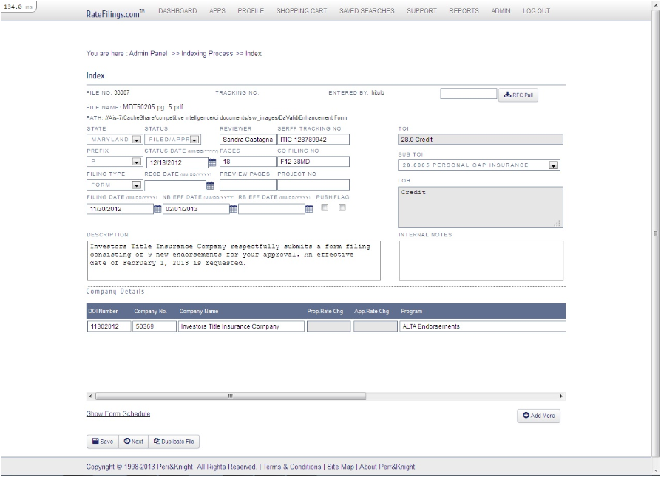

##### Indexer Extract Screen

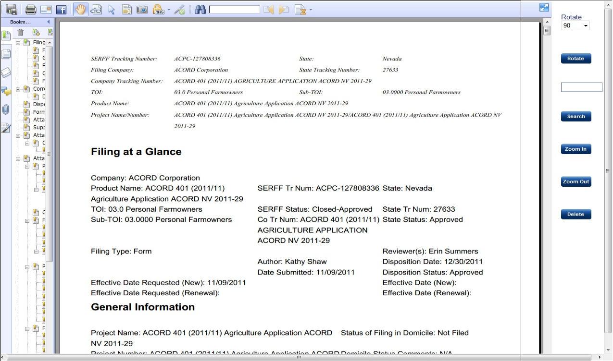

##### Indexer PDF Window

## Extract Process

### UC-PKI-AI-8 - Extract Process

Extract Process Extract the Data from Pdf files and Store the data in Database

|  |  |
| --- | --- |
| Preconditions Pre-decided folder contains PDF file and the PDF file is valid PDF. | Success Guarantee System extracts required data from all pdf files |

#### Main Success Scenario

1. System pick up PDF file from the pre-defined folder.
2. System opens the PDF files.
3. if System opened PDF successfully.
   1. System update status for valid PDF file.
   2. System stores all the valid PDF files in valid file folder.
4. System Extracts data from Pdf file from SERFFmapping_2 as per mapping given in step 5, 6 and 7,8,9,10,11
5. System maps data to related fields in the "**Filing at a Glance"** section from SERFFmapping_2 pdf files .
   1. If Prefix is Health or Life.
      1. System refer TOI_Sub_TOI_to_LOB_and_Prefix sheet for Program.
   2. If Prefix is other than Health or Life.
      1. System extract Product name from pdf file to displays program.
   3. System maps Filing type with filing type .
   4. System maps SERFF tracking number with SERFF Tr Num.
   5. System maps state with state.
   6. System maps DOI number with State Tr Num.
   7. System maps Date submitted with PN/Filing date.
   8. System maps Status date with Disposition date.
   9. System maps Status with Disposition status.
   10. System maps NB EFF date with Effective Date(New).
   11. System maps RB EFF date with Effective Date(Renewal).
   12. System maps Reviewer(s) with Reviewer.
   13. System maps Sub-TOI field with Sub-TOI.
   14. System maps with Sub_TOI and Reffers combination of Sub-TOI and TOI , TOI_Sub_TOI_to_LOB_and_Prefix sheet for Prefix.
   15. If Prefix is Health or Life.
       1. System maps with Sub-TOI field and refers TOI_Sub_TOI_to_LOB_and_Prefix sheet for LOB.
       2. System maps with Sub-TOI and refers TOI_Sub_TOI_to_LOB_and_Prefix sheet for TOI.
   16. If Prefix is other than Health or Life.
       1. System maps LOB with TOI from PDF File.
       2. System maps TOI with TOI from PDF File.
   17. System maps Description with Filing Description.
6. System maps data related fields in the **"Form Schedule"** section.
   1. System searchs Item No. string and stores the coordinates to the variable '**start**'
   2. System searches next location of Item No. and stores the coordinate to the variable '**end**'
   3. system stores the string in variable '**FormDtlString**' with '**start**' and '**end**' variable.
7. system searches the following fields in the '**FormDtlString**'.
   1. system searches Form Name in the header row and stores the coordinate to variable '**formnameid**'.
   2. system searches Form Number in the header row and stores the coordinate to variable '**formnoid**'.
   3. system searches Edition Date in the header row and stores the coordinate to variable '**editiondateid**'.
   4. system searches Form Type in the header row and stores the coordinate to variable '**formtypeid**'.
   5. system searches Form Action in the header row and stores the coordinate to variable '**formactionid**'.
8. System searches for the Next Item No. get the **start** and **end** point and extract string in to '**FormDtlString**'.
   1. system searches for '**formactionid**' and maps the value with Form Action
   2. system checks whether Form Action value is "New"
      1. system searches for '**formnameid**' and maps the value with Form Name
      2. system searches for '**formnoid**' and maps the value with Form Number
      3. system searches for '**edtiondateid**' and maps the value with Edition Date
      4. system searches for '**formtypeid**' and maps the value with Item Form Type
   3. Go to step no. 8
9. System maps data to related fields in the **"File Company Information"** section.
   1. System maps Company name with Filing Company name.
   2. System maps Company/NAIC no with CoCode.
   3. System store Group code in database.
   4. System store Group name in database.
10. System maps data to related fields in the **"Filing Contact Information"** section.
    1. System store the Filer name data in database.
    2. .System store the Filer Email Address data in database.
    3. System store the Filer phone No data in database.
    4. System store the Filer Address data in database.
11. System maps ObjLetterFlag with Objection Letter keyword.
    1. System searches the phrase "Objection Letter" in PDF files.
       1. System find phrase " Objection Letter" successfully.
          1. System store "Yes" in database.
12. System store Project number in database from **"General Information"** section.
13. System maps Prop. Rate Change with value of "Overall percentage Rate impact for this filing" in the **"Disposition"** section.
14. System maps Overall Indicated Change with value of "Overall % Indicated Change" in the **"Disposition"** section.
15. System maps Prop. Rate Change with value of "Overall % Rate impact" from Overall % Indicated Changesection.
16. System maps Written Premium Change with value of "Written Premium Change for this program" from the Overall % Rate impactsection.
17. System maps No of Policy Affected with value of "No of Policy Holder Affected for this program" from the Written Premium Changesection.
18. System maps Written Premium with value of "Written Premium for this Program" from the No of Policy Affectedsection.
19. If Status of Dispositions is Filed/Approved in the **"Correspondence Summary"** section, App. Rate change is same as Prop. Rate Change.
20. System Stores the data in the database.
21. System calculate the no. of pages in the PDF file.
    1. System displays page count in Pages field.
       1. System Stores the page count in the database.
22. System Checks Extracted Pdf File is not Duplicate
    1. System Gets the SerffTrackingNo ,Internal notes and State of Extracted files.
    2. System checks in filing table whether SerffTrackingNo Exist in SerffTrackingNo Column or Internal Notes column for the State to which filing belong.
    3. Filing table doest not contain SerffTrackingNo
       1. Go to Step No. 23
23. System Checks Extracted Number of field
    1. If No of Fields = 0
       1. System update PdfFileStsId with status 'Extract None'
    2. If No of Fields > 0 and <32
       1. System update PdfFileStsId with status 'Extract Partial'
    3. If No of Fields > = 32
       1. System update PdfFileStsId with status 'Extract Full'
24. System invokes use case Allocation Process (UC-PKI-AI-9)

#### Extensions

3.a System fails to open PDF file.

1. System update status for invalid PDF files.

2. System stores all the invalid PDF files in Invalid file folder

3. Go to next available PDF file.

4. Continue from step No. 1

5.5.a State field not available.

1. System maps State field with Filing Company.

5.6.a State Tr Num is not available

1. System maps DOI no with Company Tracking Number

5.10.a Effective Date(New) date field is empty

1. System maps as per requirement REQ-PK-AI-6

1.1. Effective Date(New) and Effective date requested(New) fields are empty.

1.1.1. System maps as per requirement REQ-PK-AI-7

1.2. Effective Date(New),Effective date requested(New) and Disposition date are empty.

1.2.1. System maps as per requirement REQ-PK-AI-8

5.11.a Effective Date(Renewal) date field is empty

1. System maps as per requirement REQ-PK-AI-9

1.1. Effective Date(Renewal) and Effective date requested(Renewal) fields are empty.

1.1.1. System maps as per requirement REQ-PK-AI-11

1.2. Effective Date(Renewal),Effective date requested(Renewal) and Disposition date are empty.

1.2.1. System maps as per requirement REQ-PK-AI-10

8.a System does not find the Item No.

1. System saves the Form Schedule information into the Database.

2. go to step 9.

8.2.a System does not extract the values and moves to step no. 8

8.2.1.a system does not found 'formnameid' and maps the null value.

8.2.2.a system does not found 'formnoid' and maps the null value.

8.2.3.a system does not found 'editiondateid' and maps the null value.

8.2.4.a system does not found 'formtypeid' and maps the null value.

9.1.a Company name not present.

1. System maps Company name with CoCode.

9.2.a Company/NAIC no. not present.

1. System maps Company/NAIC no with Filing Company name.

11.1.1.a System fails to find "Objection Letter" phrase.

1. System store "No" in database.

19.a If Status of Dispositions is Pending, Disapproved/Withdrawn in the "Correspondence Summary" section, App. Rate change should be blank.

22.3.a Filing table contains SerffTrakingNo.

1. System Updates PdfFileStsId and RFCNo of Pdffile table with 'DupliacateFiling' and Searched RFCNo.

2. System moves PdfFile From DaValid_Live Folder to DaDup_Live Folder.

3. System updates PdfFilePath with Duplicate file path location

4. Go to Step No. 1

|  |
| --- |
| Related Documents |
| [SERFF mapping_2.pdf](SERFF%20mapping_2.pdf) |

* 2/4/2013 Enhancement of Q1 Jan Release 01/04/2013 for the AI Extraction Process for Filing Type 'Form'

##### Activity Diagram

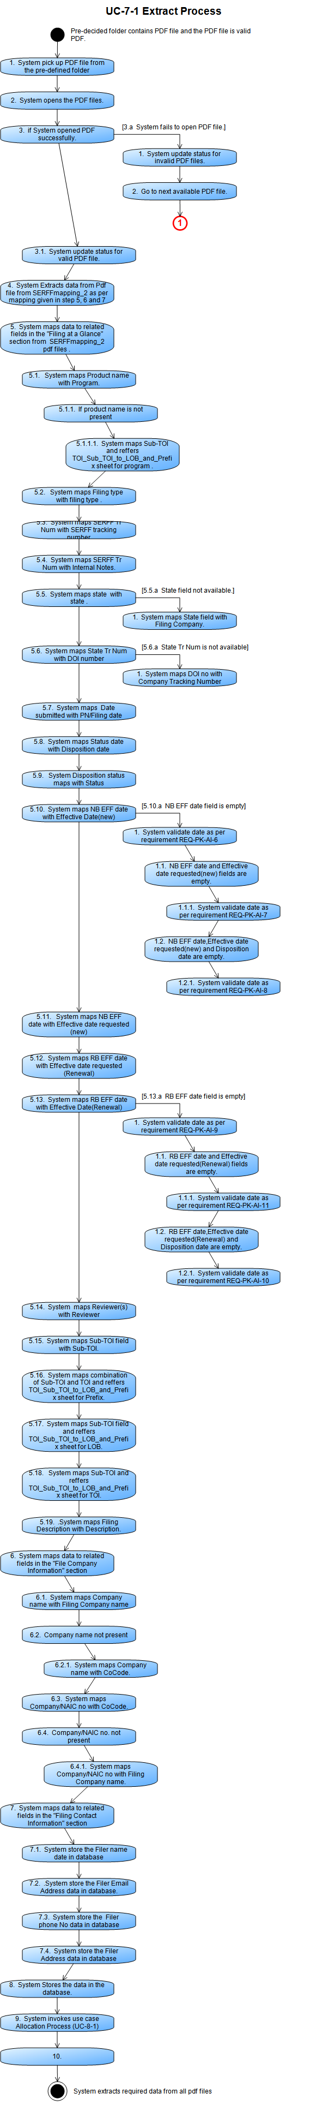

# 

# Actors



|  |  |  |
| --- | --- | --- |
| Name | Description | Participates in |
| Admin (A-PKI-AI-3) |  |  |
| Auditor (A-PKI-AI-5) |  | UC-PKI-AI-6 QC Process |
| Indexer (A-PKI-AI-4) |  | UC-PKI-AI-2 Indexer Process |
| System (A-PKI-AI-1) |  | UC-PKI-AI-2 Indexer Process  UC-PKI-AI-6 QC Process  UC-PKI-AI-8 Extract Process  UC-PKI-AI-9 Allocation Process |
| User (A-PKI-AI-2) |  |  |

# Requirements

|  |  |  |
| --- | --- | --- |
| Requirement | Description | Type |
| REQ-PKI-AI-2  REQ-PK-AI-1 | The date should be in the form of MM/DD/YYYY. | Non-functional |
| REQ-PKI-AI-4  REQ-PK-AI-12 | Date should be in the form of MM/DD/YYYY | Non-functional |
| REQ-PKI-AI-5  REQ-PK-AI-13 | The date should be in the form of MM/DD/YYYY.  To date is required when from date is filled. | Non-functional |
| REQ-PKI-AI-6  REQ-PK-AI-14 | The date should be in the form of MM/DD/YYYY  From date is required When To date is filled. | Non-functional |
| REQ-PKI-AI-6  REQ-PK-AI-3 | The year of NB EFF date should be within 5 years from the filing date. | Non-functional |
| REQ-PKI-AI-7  REQ-PK-AI-4 | The year of RB EFF date should be within 5 years from the filing date. | Non-functional |
| REQ-PKI-AI-7  REQ-PK-AI-2 | The Date should be current date.  The Date should be in the form of MM/DD/YYYY. | Non-functional |
| REQ-PKI-AI-8  REQ-PK-AI-6 | System maps NB EFF date with Effective Date Requested(New). | Non-functional |
| REQ-PKI-AI-9  REQ-PK-AI-7 | System maps NB EFF Date with Disposition Date. | Non-functional |
| REQ-PKI-AI-10  REQ-PK-AI-8 | System maps NB EFF Date with Date Submitted. | Non-functional |
| REQ-PKI-AI-11  REQ-PK-AI-9 | System maps RB EFF date with Effective Date Requested(Renewal). | Non-functional |
| REQ-PKI-AI-12  REQ-PK-AI-10 | System maps RB EFF Date with Date Submitted. | Non-functional |
| REQ-PKI-AI-13  REQ-PK-AI-11 | System maps RB EFF Date with Disposition Date. | Non-functional |

# Glossary

# Open Issues